# **ANALYSIS OF ELECTRIC VEHICLE CHARGING PATTERNS**

Name: Balaji Manjulamma Sriramareddy

Student Id: 23017949

**Introduction**:

The electric vehicle (EV) industry is buzzing with change, and understanding how users charge their vehicles is more important than ever. In this report, we dive into a dataset featuring 1,320 EV charging sessions, which reveals key insights about energy consumption, charging durations, and the types of vehicles involved. Our goal is to uncover trends that can help optimize charging infrastructure and improve the overall user experience for EV owners.

**Analysis of Charger Types**

The pie chart below showcases the distribution of different charger types used across the dataset.

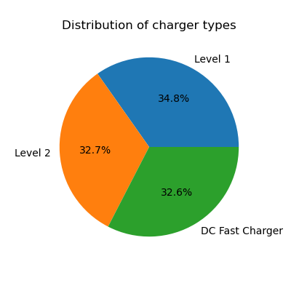

This pie chart gives us a captivating glimpse into the different charger types that users chose during their charging sessions. It’s interesting to see that Level 1 chargers are the most popular, accounting for 34.8% of the total. They’re closely followed by Level 2 chargers at 32.7% and DC fast chargers at 32.6%. This nearly equal distribution among the charger types shows that users have a variety of preferences when it comes to how they charge their vehicles.

**Analysis of Energy Consumed vs. Charging Duration**

The scatter plot below illustrates the relationship between charging duration and energy consumed, differentiated by vehicle model.

One trend we can clearly see is that, as the charging duration increases, the energy consumed typically rises as well. This is exactly what we would expect—longer charging sessions usually mean more energy usage. However, there’s a lot of variation between different vehicle models.

For example, the BMW i3 really grabs our attention, as it consumes over 140 kWh in just 1 hour of charging! This indicates that the BMW i3 has a much higher energy demand compared to other models.

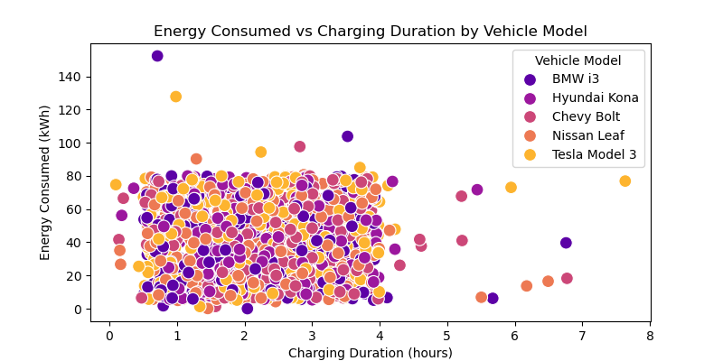

**Analysis of Correlation Heatmap**

The heatmap below illustrates the correlation between key features in the dataset, providing a visual representation of how different variables relate to one another.

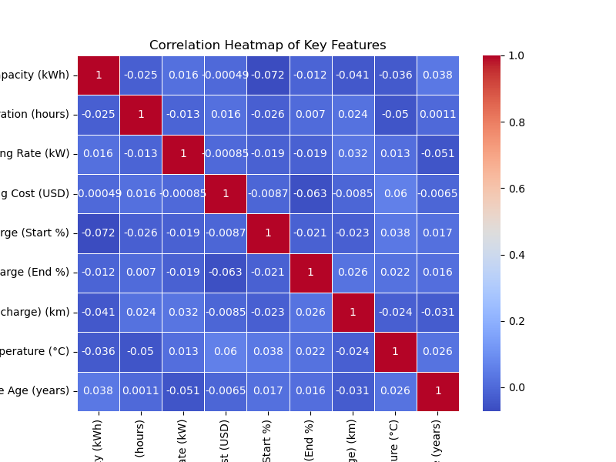

The analysis shows that battery capacity and charging duration have very weak correlations with other features, with the strongest correlation being just -0.072 between battery capacity and state of charge (Start %). Charging duration has minimal links, especially with temperature, while charging rate and charging cost also show weak relationships. Overall, the state of charge patterns have similarly weak correlations with other variables.

**Conclusion**

In exploring EV charging patterns, we’ve uncovered valuable insights that illuminate user behaviors and open the door to greater operational efficiency. By grasping these trends, stakeholders can make informed decisions that help shape a stronger EV infrastructure. Ultimately, this will lead to an improved experience for all electric vehicle users, making it easier and more enjoyable for everyone to charge their vehicles and embrace the benefits of electric driving.

Git Link: